**COMPUTER SCIENCE**

**PROJECT FILE ON**

**Student Report Card Management**



**PROJECT PREPARED BY:**

**Devansh Chauhan Abhishek Saxena**

**XII A XII B**

**Session: 2019-20 Session: 2019-20**

**N.C.Jindal public School N.C.Jindal public School**

**TABLE OF CONTENTS**

* **Certificate**
* **Acknowledgement**
* **Header files and their purpose**
* **Coding**
* **Output screen**
* **Limitations**
* **Requirements**
* **Bibliography**

**Acknowledgement**

**I thank my Computer Science teacher Mrs. Vijay lakshmi gupta for guidance and support. I also thank my Principal Dr. D.k Pandey.I would also like to thank my parents for encouraging me during the course of this project. Finally I would like to thank CBSE for giving me this opportunity to undertake this project.**

**Certificate**

**This is to certify that Devansh chauhan and Abhishek Saxena of class 12, N.C jindal public School, Punjabi bagh,New Delhi has successfully completed his project on Student report card management as prescribed by CBSE in the year 2019-20.**

**Date :**

**Registration No. :**

**Signature of Internal Signature of External**

**Examiner Examiner**

**__________________ __________________**

**HEADER FILES USED AND THEIR PURPOSE**

1. **FSTREAM.H**  for file handling, cin and cout
2. **PROCESS.H**  for exit() function
3. **CONIO.H**  for clrscr() and getch() functions
4. **STDIO.H**  for standard I/O operations
5. **STRING.H**  for string handling
6. **CTYPE.H**  for character handling

CODING

**#include<graphics.h>**

**#include<conio.h>**

**#include<stdio.h>**

**#include<process.h>**

**#include<fstream.h>**

**#include<iomanip.h>**

**#include<stdlib.h>**

**#include<dos.h>**

**char ch;**

**class student**

**{**

**int rollno;**

**char name[50];**

**int p_marks,c_marks,m_marks,e_marks,cs_marks;**

**float per;**

**char grade;**

**int std;**

**void calculate()**

**{**

**per=(p_marks+c_marks+m_marks+e_marks+cs_marks)/5.0;**

**if(per>=80)**

**grade='A';**

**else if(per>=60 && per<80)**

**grade='B';**

**else if(per>=33 && per<60)**

**grade='C';**

**else**

**grade='F';**

**}**

**public:**

**void getdata()**

**{**

**textcolor(rand());**

**cout<<"\n"; cprintf("Enter The roll number of student ");**

**cin>>rollno;**

**cout<<"\n\n"; cprintf("Enter The Name of student ");**

**gets(name);**

**cout<<"\n"; cprintf("Enter The marks in physics out of 100 : ");**

**cin>>p_marks;**

**cout<<"\n"; cprintf("Enter The marks in chemistry out of 100 : ");**

**cin>>c_marks;**

**cout<<"\n"; cprintf("Enter The marks in maths out of 100 : ");**

**cin>>m_marks;**

**cout<<"\n"; cprintf("Enter The marks in english out of 100 : ");**

**cin>>e_marks;**

**cout<<"\n"; cprintf("Enter The marks in computer science out of 100 : ");**

**cin>>cs_marks;**

**calculate();**

**}**

**void showdata()**

**{**

**textcolor(rand()+BLINK);**

**cout<<"\n"; cprintf("Roll number of student : ");cout<<rollno;**

**cout<<"\n"; cprintf("Name of student : ");cout<<name;**

**cout<<"\n"; cprintf("Marks in Physics : ");cout<<p_marks;**

**cout<<"\n"; cprintf("Marks in Chemistry : ");cout<<c_marks;**

**cout<<"\n"; cprintf("Marks in Maths : ");cout<<m_marks;**

**cout<<"\n"; cprintf("Marks in English : ");cout<<e_marks;**

**cout<<"\n"; cprintf("Marks in Computer Science :");cout<<cs_marks;**

**cout<<"\n"; cprintf("Percentage of student is :");cout<<setprecision(2)<<per;**

**cout<<"\n"; cprintf("Grade of student is :");cout<<grade;**

**}**

**void show_tabular()**

**{**

**cout<<rollno<<setw(12)<<name<<setw(10)<<p_marks<<" "<<c_marks<<" "<<m_marks<<" "<<e_marks<<" "<<cs_marks<<" "<<setprecision(3)<<per<<" "<<grade<<endl;**

**}**

**int retrollno()**

**{return rollno;}**

**};**

**fstream fp;**

**student st;**

**void write_student()**

**{**

**textcolor(rand() );**

**fp.open("student.txt",ios::out|ios::app);**

**st.getdata();**

**fp.write((char*)&st,sizeof(student));**

**fp.close();**

**cout<<"\n\n"; cprintf("student record Has Been Created ");**

**getch();**

**}**

**void display_all()**

**{**

**clrscr();**

**textcolor(rand() );**

**cout<<"\n\n\n\t\t"; cprintf("DISPLAY ALL RECORD !!!");cout<<"\n\n";**

**fp.open("student.txt",ios::in);**

**while(fp.read((char*)&st,sizeof(student)))**

**{**

**st.showdata();**

**cout<<"\n\n";cprintf("====================================");cout<<"\n";**

**getch();**

**}**

**fp.close();**

**getch();**

**}**

**void display_sp(int n)**

**{**

**textcolor(rand() );**

**int flag=0;**

**fp.open("student.txt",ios::in);**

**while(fp.read((char*)&st,sizeof(student)))**

**{**

**if(st.retrollno()==n)**

**{**

**clrscr();**

**st.showdata();**

**flag=1;**

**}**

**}**

**fp.close();**

**if(flag==0)**

**cout<<"\n\n"; cprintf("record not exist");**

**getch();**

**}**

**void modify_student()**

**{**

**textcolor(rand() );**

**int no,found=0;**

**clrscr();**

**cout<<"\n\n\t"; cprintf("To Modify ");**

**cout<<"\n\n\t"; cprintf("Please Enter The roll number of student");**

**cin>>no;**

**fp.open("student.txt",ios::in|ios::out);**

**while(fp.read((char*)&st,sizeof(student)) && found==0)**

**{**

**if(st.retrollno()==no)**

**{**

**st.showdata();**

**cout<<"\n"; cprintf("Please Enter The New Details of student");cout<<endl;**

**st.getdata();**

**int pos=-1*sizeof(st);**

**fp.seekp(pos,ios::cur);**

**fp.write((char*)&st,sizeof(student));**

**cout<<"\n\n\t"; cprintf(" Record Updated");**

**found=1;**

**}**

**}**

**fp.close();**

**if(found==0)**

**cout<<"\n\n"; cprintf(" Record Not Found ");**

**getch();**

**}**

**void delete_student()**

**{**

**textcolor(rand() );**

**int no;**

**clrscr();**

**cout<<"\n\n\n\t"; cprintf("Delete Record");**

**cout<<"\n\n"; cprintf("Please Enter The roll number of student You Want To Delete");**

**cin>>no;**

**fp.open("student.txt",ios::in|ios::out);**

**fstream fp2;**

**fp2.open("Temp.dat",ios::out);**

**fp.seekg(0,ios::beg);**

**while(fp.read((char*)&st,sizeof(student)))**

**{**

**if(st.retrollno()!=no)**

**{**

**fp2.write((char*)&st,sizeof(student));**

**}**

**}**

**fp2.close();**

**fp.close();**

**remove("student.txt");**

**rename("Temp.txt","student.txt");**

**cout<<"\n\n\t"; cprintf("Record Deleted ..");**

**getch();**

**}**

**void class_result()**

**{**

**textcolor(rand() );**

**clrscr();**

**fp.open("student.txt",ios::in);**

**if(!fp)**

**{**

**cprintf("ERROR!!! FILE COULD NOT BE OPEN");cout<<"\n\n\n";cprintf(" Go To Entry Menu to create File");**

**cout<<"\n\n\n"; cprintf(" Program is closing ....");**

**getch();**

**exit(0);**

**}**

**cout<<"\n\n\t\t"; cprintf("ALL STUDENTS RESULT ");cout<<"\n\n";**

**cprintf("====================================================");cout<<"\n";**

**cprintf("Roll No. Name P C M E CS %age Grade"); cout<<"\n";**

**cprintf("====================================================");cout<<"\n";**

**while(fp.read((char*)&st,sizeof(student)))**

**{**

**st.show_tabular();**

**}**

**fp.close();**

**getch();**

**}**

**void result()**

**{**

**textcolor(rand() );**

**int ans,rno;**

**char ch;**

**clrscr();**

**cout<<"\n\n\n"; cprintf("RESULT MENU");**

**cout<<"\n\n\n"; cprintf("1. Class Result");cout<<"\n\n";cprintf("2. Student Report Card");cout<<"\n\n";cprintf("3.Back to Main Menu");**

**cout<<"\n\n\n"; cprintf("Enter Choice (1/2)? ");**

**cin>>ans;**

**switch(ans)**

**{**

**case 1 : class_result();break;**

**case 2 : {**

**do{**

**clrscr();**

**char ans;**

**cout<<"\n\n";cprintf("Enter Roll Number Of Student : ");**

**cin>>rno;**

**display_sp(rno);**

**cout<<"\n\n";cprintf("Do you want to See More Result (y/n)?");**

**cin>>ans;**

**}while(ans=='y'||ans=='Y');**

**break;**

**}**

**case 3: break;**

**default: cout<<"\a";**

**}**

**}**

**void intro()**

**{**

**clrscr();**

**textcolor(rand() );**

**cout<<"\n\n\n\n\n\n\t\t\t"; cprintf("STUDENT");**

**cout<<"\n\t\t\t"; cprintf(" REPORT CARD");**

**cout<<"\n\t\t\t\t\t"; cprintf("PROJECT");**

**cout<<"\n\n\n\t\t"; cprintf("MADE BY : DEVANSH CHAUHAN AND ABHISHEK SAXENA");**

**cout<<"\n\n\n\t\t"; cprintf("SCHOOL : N.C JINDAL PUBLIC SCHOOL");**

**cout<<"\n\n\n\t\t"; cprintf("ADDRESS : PUNJABI BAGH,NEW DELHI-110026");**

**getch();**

**}**

**void entry_menu()**

**{**

**clrscr();**

**textcolor(rand() );**

**char ch2;**

**cout<<"\n\n\n\t"; cprintf("\n\n\n\tENTRY MENU");**

**cout<<"\n\n\t"; cprintf("1.CREATE STUDENT RECORD");**

**cout<<"\n\n\t"; cprintf("2.DISPLAY ALL STUDENTS RECORDS");**

**cout<<"\n\n\t"; cprintf("3.SEARCH STUDENT RECORD ");**

**cout<<"\n\n\t"; cprintf("4.MODIFY STUDENT RECORD");**

**cout<<"\n\n\t"; cprintf("5.DELETE STUDENT RECORD");**

**cout<<"\n\n\t"; cprintf("6.BACK TO MAIN MENU");**

**cout<<"\n\n\t"; cprintf("Please Enter Your Choice (1-6) ");**

**ch2=getche();**

**switch(ch2)**

**{**

**case '1': clrscr();**

**write_student();**

**break;**

**case '2': display_all();break;**

**case '3':**

**int num;**

**clrscr();**

**cout<<"\n\n\t"; cprintf("Please Enter The roll number ");**

**cin>>num;**

**display_sp(num);**

**break;**

**case '4': modify_student();break;**

**case '5': delete_student();break;**

**case '6': break;**

**default:cout<<"\a";entry_menu();**

**}**

**}**

**void loading()**

**{**

**clrscr();**

**int x,y,i;**

**int g=DETECT, d;**

**initgraph(&g, &d,"C:\\TC\\BGI");**

**cleardevice();**

**x=getmaxx()/2;**

**y=getmaxy()/2;**

**settextstyle(TRIPLEX_FONT,HORIZ_DIR,3);**

**setbkcolor(rand());**

**setcolor(rand());**

**int c=150;**

**for(int e=0;e<40;e++)**

**{**

**for(int i=50;i<100;i++)**

**{**

**setcolor(rand());**

**settextstyle(SMALL_FONT, HORIZ_DIR, 10);**

**outtextxy(x,y,"Loading...");**

**settextstyle(SMALL_FONT, HORIZ_DIR, 5);**

**outtextxy(x+5,y+5,"Please Wait... ");**

**circle(x,y,i);**

**circle(x,y,c);**

**c--;**

**cleardevice();**

**}**

**}**

**setcolor(2);**

**settextstyle( DEFAULT_FONT, HORIZ_DIR, 9);**

**settextjustify(x,y);**

**outtextxy(x-250,y-190,"WELCOME");**

**delay(150);**

**outtextxy(x-90,y-90,"TO");**

**delay(150);**

**for(int i1=0;i1<=14;i1++)**

**{**

**for(i1=0;i1<=14;i1++)**

**{**

**setcolor(rand());**

**settextstyle( DEFAULT_FONT, HORIZ_DIR, 7);**

**settextjustify(x,y);**

**outtextxy(x-280,y+30,"N.C.JINDAL");**

**delay(50);**

**settextstyle( DEFAULT_FONT, HORIZ_DIR, 9);**

**settextjustify(x,y);**

**outtextxy(x-200,y+130,"SCHOOL");**

**delay(50);**

**}**

**}**

**closegraph();**

**}**

**void apass()**

**{**

**clrscr();**

**textcolor(rand() );**

**int i,flag=0;**

**char ap[9]="mrchauhan";**

**char user[9];**

**do{**

**cprintf("Enter the password : ");**

**for(i=0;i<=8;i++)**

**{**

**user[i]=getch();**

**cprintf("*");**

**}**

**for(i=0;i<=8;i++)**

**{if(user[i]==ap[i])**

**flag++;**

**}**

**if(flag==9)**

**{**

**clrscr();**

**textcolor(rand() );**

**cout<<"\n\n\n\n\n\n\n\t\t\t";**

**cprintf(" PASSWORD AUTHENTICATED");cout<<"\n\n\t\t\t";cprintf(" welcome sir");**

**delay(100);**

**for(i=0;i<=10;i++)**

**{**

**cprintf(".");**

**delay(200);**

**}**

**ch='y';**

**break;**

**}**

**else**

**{**

**flag=0;**

**cout<<"\n";**

**cprintf("Wrong password");**

**cout<<"\n";**

**cprintf("Do you want to continue (y/n) : ");**

**cin>>ch;**

**}**

**}while(ch=='y'||ch=='Y');**

**}**

**void main()**

**{**

**char ch1;**

**loading();**

**intro();**

**apass();**

**if(ch=='n'||ch=='N')**

**exit(0);**

**do**

**{**

**clrscr();**

**textcolor(GREEN );**

**cout<<"\n\n\n\t"; cprintf("MAIN MENU");**

**cout<<"\n\n\t"; cprintf("01. RESULT MENU");**

**cout<<"\n\n\t"; cprintf("02. ENTRY/EDIT MENU");**

**cout<<"\n\n\t"; cprintf("03. EXIT");**

**cout<<"\n\n\t"; cprintf("Please Select Your Option (1-3) ");**

**ch1=getche();**

**switch(ch1)**

**{**

**case '1': clrscr();**

**result();**

**break;**

**case '2': entry_menu();**

**break;**

**case '3':exit(0);**

**default :cout<<"\a";**

**}**

**}while(ch!='3');**

**}**

**output screen**



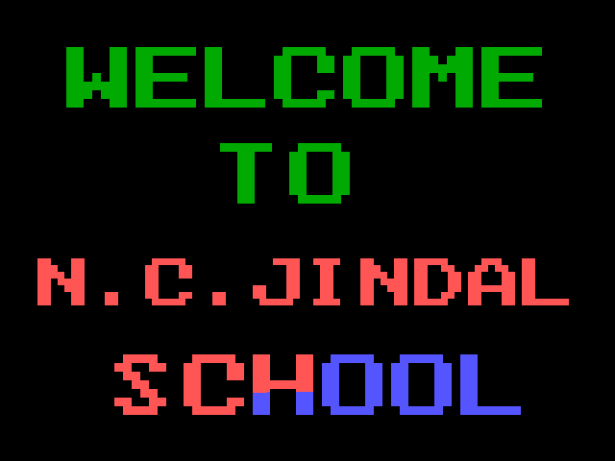

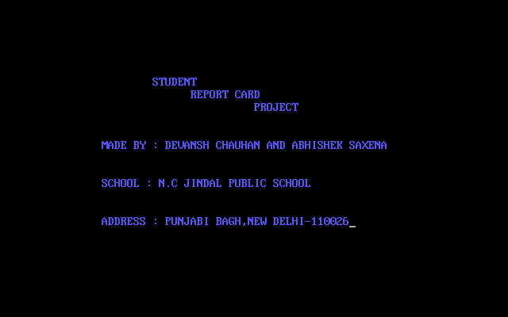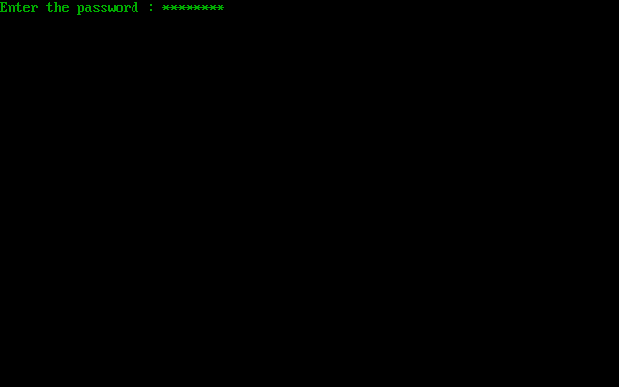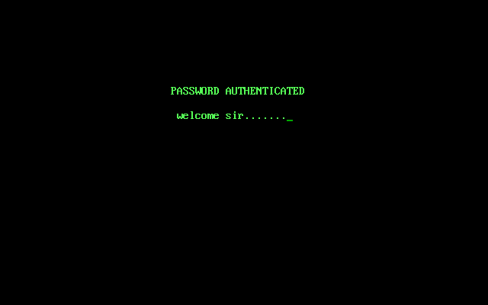

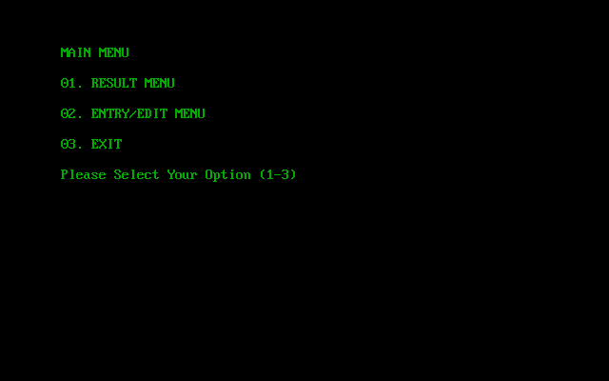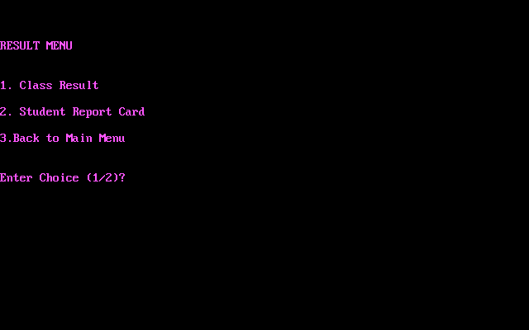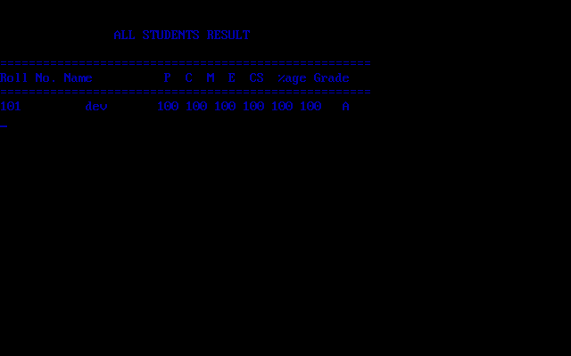

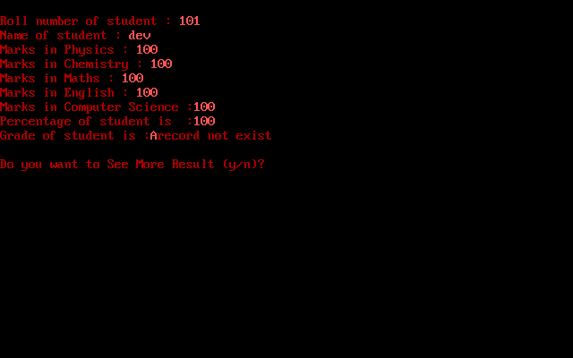

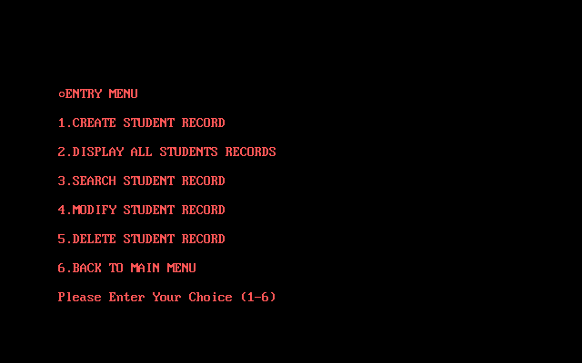

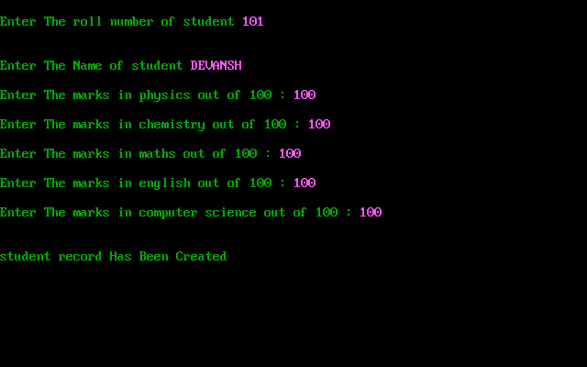

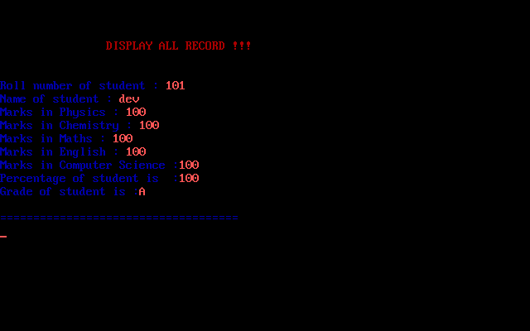

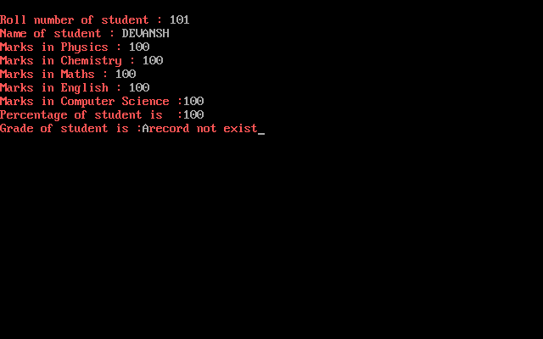

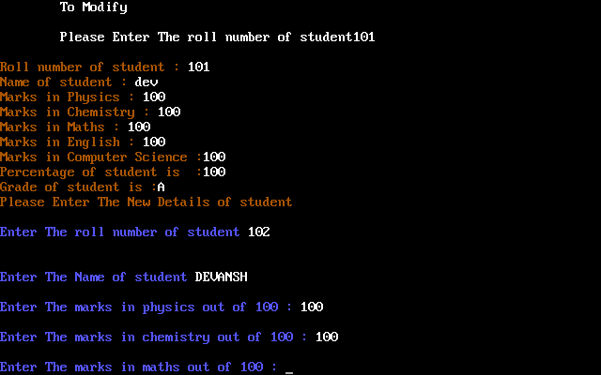

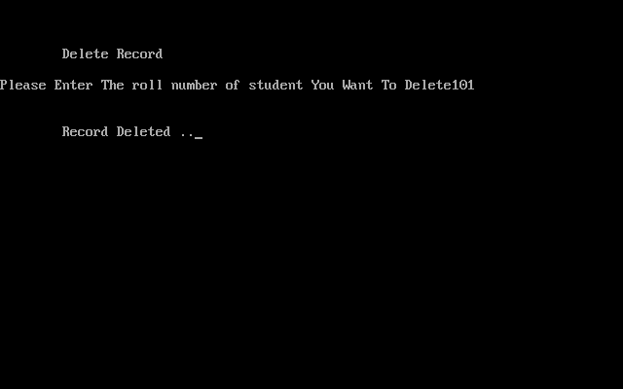

**Requirements**

* **Hardware Required**
* **Printer, to print the required documents of the project**
* **Compact Drive**
* **Processor : Pentium III**
* **Ram : 64 MB**
* **Harddisk : 20 Gb.**
* **software Required**
* **Operating system : Windows XP**
* **Turbo C++, for execution of program and**
* **Ms word, for presenattion of output.**

**BIBLIOGRAPHY**

j0292020

**COMPUTER SCIENCE IN C++ BY : Preeti arora**